**Prepositions & the Imperative**

|  |  |
| --- | --- |
| Prepositions are a class of words that indicate relationships between nouns, pronouns and other words in a sentence. Most often they come before a noun. They never change their form, regardless of the case, gender etc. of the word they are referring to. |  |

Some common prepositions are:

|  |  |  |  |
| --- | --- | --- | --- |
| About (autour de) above (au-dessus) across (à travers) after (après) against (contre) along (le long de) among (parmi/entre) around (autour) at (à) before (avant/avant de) behind (derrière) below (dessous/en dessous) beneath (sous) beside (à côté de) between (entre) beyond (au-delà de) but (mais) | By (près de) despite (malgré/quoique) down (vers le bas/en bas) during (pendant) except (sauf)  for (pour)  from (à partir de/depuis/de) in (dans/en/à) inside (dans/au-dedans) into (dans/en) like (comme) near (proche/près) of (en/de) off (hors de) on (sur) onto (sur) (paper) out (dehors) | | Outside (extérieur) over (sur/plus/au-dessus de) past (après) since (depuis/dès)  through (par) throughout (partout) till (jusqu’à) to (pour/jusqu’à/à/de) toward (dans la direction de) under (selon) underneath (sous) until (jusqu’à/avant) up (en haut) upon (sur) with (avec/chez) within (dans) without (sans) |
| Prepositions typically come before a noun: | | * **after** class * **at** home * **before** Tuesday * **in** London * **on** fire * **with** pleasure | | |
| A preposition usually indicates the temporal, spatial or logical relationship of its object to the rest of the sentence. | | * The book is on the table. * The book is beside the table. * She read the book during class. | | |
| Prepositions are classified as simple or compound. **Simple prepositions** Simple prepositions are single word prepositions. | | * The book is **on** the table. | | |
| **Compound prepositions** Compound prepositions are more than one word. **in between**and**because of**are prepositions made up of two words - **in front of, on behalf of**are prepositions made up of three words. | | * The book is in between War and Peace and The Lord of the Rings. * The book is in front of the clock. | | |

The following table contains rules for some of the most frequently used prepositions in English:

**Prepositions of Time:**

|  |  |  |
| --- | --- | --- |
| **English** | **Usage** | **Example** |
| * on | * days of the week | * on Monday |
| * in | * months / seasons * time of day * year * after a certain period of time *(when?)* | * in August / in winter * in the morning * in 2006 * in an hour |
| * at | * for *night* * for *weekend* * a certain point of time*(when?)* | * at night * at the weekend * at half past nine |
| * since | * from a certain point of time (past till now) | * since 1980 |
| * for | * over a certain period of time (past till now) | * for 2 years |
| * ago | * a certain time in the past | * 2 years ago |
| * before | * earlier than a certain point of time | * before 2004 |
| * to | * telling the time | * ten to six (5:50) |
| * past | * telling the time | * ten past six (6:10) |
| * to / till / until | * marking the beginning and end of a period of time | * from Monday to/till Friday |
| * till / until | * in the sense of *how long something is going to last* | * He is on holiday until Friday. |
| * by | * in the sense of *at the latest* * up to a certain time | * I will be back by 6 o’clock. * By 11 o'clock, I had read five pages. |

**Prepositions of Place:**

|  |  |  |
| --- | --- | --- |
| **English** | **Usage** | **Example** |
| * in | * room, building, street, town, country * book, paper etc. * car, taxi * picture, world | * in the office, in London * in the book * in the car, in a taxi * in the picture, in the world |
| * at | * meaning *next to, by an object* * for *table* * for events * place where you are to do something typical (watch a film, study, work) | * at the door, at the station * at the table * at a concert, at the party * at the cinema, at school, at work |
| * on | * attached * for a place with a river * being on a surface * for a certain side (left, right) * for a floor in a house * for public transport * for *television, radio* | * the picture on the wall * London lies on the Thames. * on the table * on the left * on the first floor * on the bus, on a plane * on TV, on the radio |
| * by, next to, beside | * left or right of somebody or something | * Jane is standing by / next to / beside the copier. |
| * under | * on the ground, lower than (or covered by) something else | * the bag is under the table |
| * below | * lower than something else but above ground | * the paper is below the cover |
| * over | * covered by something else * meaning *more than* * getting to the other side (also *across*) * overcoming an obstacle | * put a jacket over your shirt * over 16 years of age * walk over the bridge * climb over the wall |
| * above | * higher than something else, but not directly over it | * a path above the lake |
| * across | * getting to the other side (also *over*) * getting to the other side | * walk across the bridge * swim across the lake |
| * through | * something with limits on top, bottom and the sides | * drive through the tunnel |
| * to | * movement to person or building * movement to a place or country * for *bed* | * go to the cinema * go to London / Ireland * go to bed |
| * into | * enter a room / a building | * go into the kitchen / the house |
| * towards | * movement in the direction of something (but not directly to it) | * go 5 steps towards the house |
| * onto | * movement to the top of something | * jump onto the table |
| * from | * in the sense of *where from* | * a flower from the   garden |

**Picture 1:**  
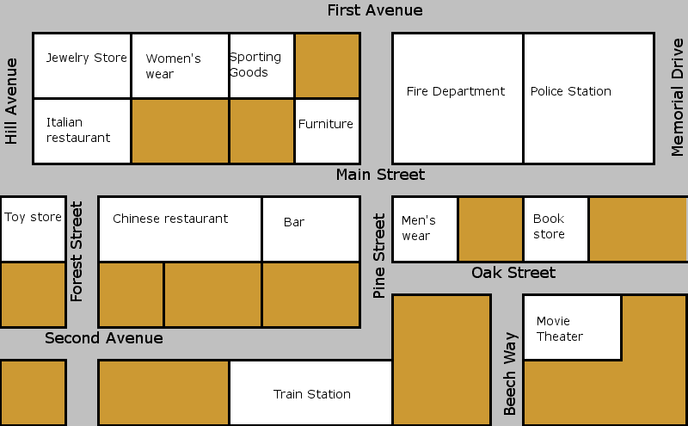

X  
You are here

**Exercise 1 : Look at Picture 1 and circle either True or False to indicate if the sentence is correct or not;**  
a. The jewelery store is behind the Italian restaurant. True / False  
b. The bar is on Second Avenue. True / False  
c. The police station is on the left from the Fire Department. True / False  
d. The toy store is across from the Chinese restaurant. True / False  
e. The movie theatre is opposite the Book store. True / False  
f. The sporting goods store is behind the Furniture store. True / False  
g. The bar is next to the Chinese restaurant. True / False

**Exercise 2 : Look at the map and choose the correct name of the building;**a. Take the first street on the left. Take the next street on the right. Go straight on and cross the road. It’s on the left.   
b. Take the street on the right and at the end turn left. Continue to the end of the street and turn left. It is opposite you.   
c. Take the first street on the left and continue until the end of the street. Turn right, go straight ahead. It’s on your left after you cross the next street.

**Exercise 3 : Look at the map and fill in the propositions;**a. The Women’s wear is ................................ the Jewelery Store.  
b. The Movie Theatre is ................................ the Book Store.  
c. The Women’s wear is ................................ the Jewelery Store and the Bar.  
d. The Toy store is ................................ Main Street and Forest Street.  
e. The Jewelery Store is ................................ the Italian Restaurant.

**Definition:** Imperatives are verbs used to give orders, commands, warning or instructions, and (if you use "please") to make a request. It is one of the three moods of an English verb (indicative, imperative and subjunctive).  
Note that an imperative sentence does not require a subject; the pronoun "you" is implied.  
  
For example:  
 Give me that tape, please.

|  |  |
| --- | --- |
| To make the imperative, use the infinitive of the verb without "to" | * Come here! * Sit down! |
| To make a negative imperative, put "do not" or "don't" before the verb: | * Don't go! * Do not walk on the grass |
| You can also use "let's" before the verb if you are including yourself in the imperative. The negative of "let's" is "let's not". | * Let's stop now. * Let's have some lunch. * Let's not argue * Let's not tell her about it. |
| **Orders**We can use the imperative to give a direct order. Adults do not usually give each other orders, unless they are in a position of authority. However, adults can give orders to children and to animals. The intonation of an order is important: each word is stressed, and the tone falls at the end of the sentence: | * Sit down now!  * "Sit", "down" and "now" are all stressed, and the tone falls on "now". * Take that chewing gum out of your mouth. * Stand up straight. * Give me the details. |
| We can use the imperative to give **instructions.** | * Open your book. * Take two tablets every evening. * Take a left and then a right. |
| **Warnings** You can use the imperative to warn someone of danger. All the words in the warning are stressed, but the last word has a higher tone than the first word: | * Sit down now!  * "Sit", "down" and "now" are all stressed, and the tone falls on "now". * Watch out! * Look out! * Don't cross! |
| **Advice** When you give advice using the imperative, the words are stressed normally. | * Don't tell him you're resigning now! Wait until Monday when he's in a better mood. * Don't drink alcohol * Don't eat heavy meals |
| **Requests** You can also use the imperative to make a request, but you should use a polite word before the verb: | * Please take a seat. * Please wait here. * Please hold the line. * Please don't smoke here. |
| We can use the imperative to make an **invitation**. | * Come in and sit down. Make yourself at home. * Please start without me. I'll be there shortly. * Have a piece of this cake. It's delicious. |
| We can use the imperative **on signs and notices**. | * Push. * Do not use. * Insert one dollar. |
| We can make the imperative 'more polite' by adding 'do'. | * Do be quiet. * Do come. * Do sit down. * Use the infinitive to form the imperative. |

Remember we can't use continuous verbs; only base verbs:  
'Stand up, please' and NOT 'Standing up, please.'

Compare these two sentences:  
1) 'Could you close the door?'  
2) 'Close the door.'

You probably think that the first sentence is more polite than the second – and you are right.

1) is a request. We are asking someone to do something.  
2) is an instruction. We are telling some what to do.

Sentence two uses an **imperative** to tell someone what to do.

*Note: we can make 'Close the door' into a request by adding 'Please' first: 'Please, close the door.'*

An imperative is *base verb* (present simple verb). Above, 'close' is the*verb*.

Imperatives are direct. Often they are used when we are angry.

|  |  |
| --- | --- |
| **affirmative sentences** | **negative sentences** |
| **Come** here. | **Don't** **come** now. |
| **Clean** the bathroom. | **Don't** **clean** the living room. |
| **Help** your father. | **Don't** **play** on the computer. |

* Use the exclamation only when you want to make an exclamation, e.g. Stop! Help!
* The imperative with **let's**:

|  |  |
| --- | --- |
| **affirmative sentences** | **negative sentences** |
| **Let's** **ask** the teacher. | **Let's** **not** **ask** the teacher. |

|  |  |
| --- | --- |
| To lift : soulever/lever/relever | To consume : consommer/ dépenser |
| To turn on : allumer | To change : changer / modifier |
| To turn off : arrêter | To (be) produced : produire / fabriquer |
| To warm up : réchauffer/se réchauffer | To reduce : réduire / diminuer |
| To cool down : refroidir | To enlarge : élargir/agrandir |
| To position/ to place : placer | To consult : consulter |
| To press : appuyer | To copy : copier |
| To insert : insérer | To collate : collecter |
| To punch holes : percer des trous | To operate : opérer/fonctionner |
| To staple : agrafer | To manipulate : manipuler |
| To interrupt : interrompre | To injure : blesser |
| To allow : permettre | To damage : endommager |
| To ensure : assurer | To use : utiliser |
| To conduct : mener / conduire | To cause : causer /entraîner |
| To unplug : débrancher | To open : ouvrir |